Name: ___________________________________________________ Date: *______________*

50

= %

**METHODS 11 MAT 1**

**Test 3 2015**

**Topics: Functions and Graphs, Exponential Functions**

**Total Time:**  *60minutes*  **Weighting:** *6% of the year.*

*This test comprises of* ***TWO sections****. The* ***first section*** *is* ***calculator free*** *where no calculators of any kind are to be used. The* ***second section*** *is* ***calculator assumed*** *where the CAS calculator may be used. All questions must be answered in both sections.* ***Answers should be rounded to 2 decimal places unless specified****. All working should be shown in the space provided. Solutions without working may not be awarded full marks. Please take the marks for each question into account when answering the question.*

**SECTION 1: CALCULATOR FREE**

**Time:** 30 minutes**Equipment Allowed:** Nil

**Marks for Section 1:** *25 marks*

**1. [4 marks: 2, 2]**

a) Find the gradient for the line perpendicular to 5x – 3y +6 = 0

b) Find the equation of the linear function parallel to x-axis and passing through (m, 3n).

**2. [5 marks: 1,2,2]**

Given f(x) = 2x + 1, evaluate:

a) f(3) b) f(1 + x)

c) Solve f(x) = 0

**3. [5 marks: 2, 3]**

Determine the equations of these functions:

a) b)

 

**4. [6 marks: 1, 2, 1, 2)**

For the graph of y = 2x2 - 8x + 1 , determine:  
 **a)** the equation of the line of symmetry

**b)** the location and nature of the turning point

**c)** the coordinates of the y intercept

**d)** sketch the graph of this function



**3. [5 marks: ½ point each]**

Below are 5 graphs and five equations in algebraic form each of one of five types put the

letters next to the appropriate

|  |  |  |
| --- | --- | --- |
|  | Graph | Algebraic form |
| linear |  |  |
| quadratic |  |  |
| cubic |  |  |
| exponential |  |  |
| reciprocal |  |  |

|  |  |  |
| --- | --- | --- |
| A | B | C |
| D | E | |  | | --- | | F | | G | | I | | H | | J | |

**END OF TEST SECTION 1**

Name: ___________________________________________________ Date: _________________

**SECTION 2: CALCULATOR ASSUMED**

**Time:** *30 minutes* **Equipment Allowed:** *1 page of notes (A4), CAS and scientific calculators*

**Marks for Section 2:** *25 marks*

**6. [4 marks: 2, 2]**

Given that the function, *y* = *f* (*x*), shown below, has a *y*-intercept of 12, and *x*-intercepts of -2, 1 and 3, determine the value of *f* (4).

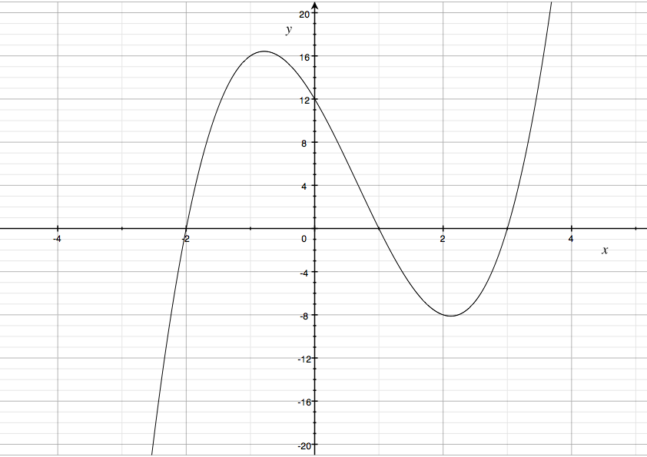

**7. [3marks]**

Given the line PQ with equation 

find coordinates of the mid point and the distance between the y-intercept of PQ and (0,4)

**8. [7marks: 1, 1, 2, 3]**

The function  is graphed below over the domain  .



a) State the equation of the line of symmetry.

b) State the range of *f* (*x*) over this domain.

c) State solutions to the equation *f* (*x*) = 0

d) Factorise –x2 + 4x – 3. Show full working out.

**9. [4marks: 2, 2]**

a) Use your knowledge of functions and graphs to determine the values of *a and b* in:





b) If the point E(*e*, -5) lies on the graph of the function above, find *e*.

**10. [7marks: 3, 4]**

The graph of y = f(x) is shown below (top row, first one on the left).

a) Match each of the following functions with its graph

i) y = f(-x) ii) y = f(x) + 2 iii) y = 2f(x)



b) Sketch the graph of y = f(x)-3 and state its the domain and y intercept.



**END OF TEST SECTION 2**